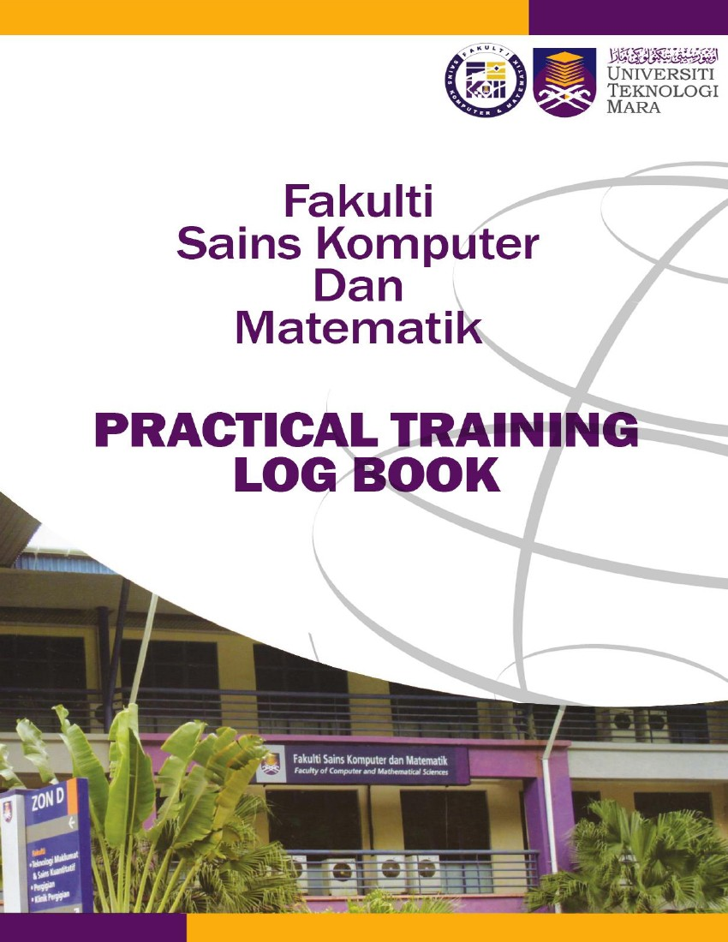


Instructions
This logbook is for you to provide a history of your industrial training and to act as a daily and/or weekly record by the work on which you are engaged.
Student’s responsibilities for keeping logbook up-to-date
Once you start your industrial training, you should consistently consult with your supervisor at the organization or supervisor-in-charge.
It is your responsibility to make the main entries of the logbook and keep it up to date. Entries
must be regularly (weekly) initialled by your Supervisor. You must ensure that:

1. Student’s name: Ahmad Suffian bin Muhammad Shahril
1. It is available at your place of work during your industrial training.
2. All entries, except sketches, are made in ink, either handwritten or typed.
3. Entries are made within a week of the work to which they refer.
4. The logbook is handed to your Academic Supervisor upon his/her visit and submitted later be
handed to the Coordinator of Industrial Training when you return to UiTM for grading.
5. The logbook contributes 10% towards your final assessment.
Recording
The log book should contain the following information.
1. A neat concise description of each of your training location and the work on which you are
engaged.
2. Relevant sketches, data, flowcharts and diagrams.
3. References to textbooks, standards and other technical information related to the work
being under taken.
4. Constructive comments on the work being undertaken and your considered opinion as to
its value as training.
5. The logbook is to be written in ENGLISH.
2. UiTM Student No: 2021494474
3. Programme Course: CS230

4. Address during Industrial Training: Level 12, Menara LGB No. 1, Jalan Wan Kadir Taman Tun Dr. Ismail, 60000 Kuala Lumpur, Malaysia
7. Name of Supervisor in-charge: Mr. Goh, Yuen Fei
5. Name of Organization: DC Technology Solutions Sdn. Bhd.
6. Address of Organization: Level 12, Menara LGB No. 1, Jalan Wan Kadir Taman Tun Dr. Ismail, 60000 Kuala Lumpur, Malaysia
8. Name of Academic Supervisor: Ahmad Fadli bin Saad (Dr.)
9. Duration of training:
From: 30th September 2024 to 3rd January 2025
FOR OFFICE USE ONLY
10. Remarks: (Coordinator of Industrial Training)
________________________________________________________________________
________________________________________________________________________
________________________________________________________________________
________________________________________________________________________
________________________________________________________________________
________________________________________________________________________
DATE | NATURE OF WORK DONE | SUPERVISOR’S REMARKS/  SIGNATURE
30/9  (Mon) | Onboarding Process:  - Attended a company briefing to understand the organization’s values and operations.  - Set up the company-issued laptop.  - Completed mandatory e-learning courses on company policies, tools, and procedures. | 
1/10  (Tues) | Mandatory Company E-Learning Courses:  - Progressed through e-learning modules on workplace ethics, data security, and compliance policies.  - Completed interactive assessments to reinforce understanding.
2/10  (Wed) | Mandatory Company E-Learning Courses:  - Continued progressing through company e-learning modules.
3/10  (Thurs) | Interns Technical E-Learning Path: Stream 1 (Front-End)  JavaScript Fundamentals (Part 1):  - Values and Variables, Data Types, Basic Operators: Learned to declare and assign variables, understand different data types (e.g., strings, numbers, booleans), and perform operations using arithmetic and logical operators.
4/10  (Fri) | Interns Technical E-Learning Path: Stream 1 (Front-End)  JavaScript Fundamentals (Part 1):  - Boolean Logic, Statements and Expressions, Functions: Explored logical operations, the difference between statements and expressions, and how to define and use functions for reusable code.

DATE | NATURE OF WORK DONE | SUPERVISOR’S REMARKS/  SIGNATURE
30/9  (Mon) | Onboarding Process:  - Attended a company briefing to understand the organization’s values and operations.  - Set up the company-issued laptop.  - Completed mandatory e-learning courses on company policies, tools, and procedures.
1/10  (Tues) | Mandatory Company E-Learning Courses:  - Progressed through e-learning modules on workplace ethics, data security, and compliance policies.  - Completed interactive assessments to reinforce understanding.
2/10  (Wed) | Mandatory Company E-Learning Courses:  - Continued progressing through company e-learning modules.
3/10  (Thurs) | Interns Technical E-Learning Path: Stream 1 (Front-End)  JavaScript Fundamentals (Part 1):  - Values and Variables, Data Types, Basic Operators: Learned to declare and assign variables, understand different data types (e.g., strings, numbers, booleans), and perform operations using arithmetic and logical operators.
4/10  (Fri) | Interns Technical E-Learning Path: Stream 1 (Front-End)  JavaScript Fundamentals (Part 1):  - Boolean Logic, Statements and Expressions, Functions: Explored logical operations, the difference between statements and expressions, and how to define and use functions for reusable code.

DATE | NATURE OF WORK DONE | SUPERVISOR’S REMARKS/  SIGNATURE
7/10  (Mon) | Interns Technical E-Learning Path: Stream 1 (Front-End)  JavaScript Fundamentals (Part 2):  - Function Declarations and Expressions, Basic Array Operations, Object Methods: Learned to define functions using declarations and expressions, manipulate arrays with basic methods, and utilize methods within objects.
8/10  (Tues) | Interns Technical E-Learning Path: Stream 1 (Front-End)  JavaScript Fundamentals (Part 2):  - Iteration, VS Code Setup, Node.js Installation: Learned iteration techniques, configured VS Code, and set up a development environment with Node.js.
9/10  (Wed) | Interns Technical E-Learning Path: Stream 1 (Front-End)  JavaScript Fundamentals (Part 2):  - DOM & Events, Data Structures, Operators, and Strings: Explored DOM manipulation, event handling, modern operators, and essential data structures.
10/10  (Thurs) | First Meeting with Mr. Deepak:  - Introduced myself, sharing my background, skills, and internship goals.  - Received a briefing on project objectives and upcoming tasks for interns.
11/10  (Fri) | Interns Technical E-Learning Path: Stream 1 (Front-End)  TypeScript:  - Introduction & Basics: Gained foundational knowledge of TypeScript, including its key concepts and syntax.

DATE | NATURE OF WORK DONE | SUPERVISOR’S REMARKS/  SIGNATURE
14/10  (Mon) | Interns Technical E-Learning Path: Stream 1 (Front-End)  - TypeScript: Learned about classes, modules, and advanced TypeScript techniques.
15/10  (Tues) | Interns Technical E-Learning Path: Stream 1 (Front-End)  - TypeScript: Installed and set up React with VS Code and Node.js. Practiced JavaScript functions and handled state in React.
16/10  (Wed) | Interns Technical E-Learning Path: Stream 1 (Front-End)  - ReactJS: Applied JavaScript functions and managed state within React components.
17/10  (Thurs) | Interns Technical E-Learning Path: Stream 1 (Front-End)  - ReactJS: Learned event handling, search functionality, logic refactoring, domain logic, filtering, and navigation with React Router.
18/10  (Fri) | Interns Technical E-Learning Path: Stream 1 (Front-End)  - ReactJS: Implemented event handling, search functionality, logic refactoring, and domain logic. Worked with modules, interpolations, array methods, and built web apps using React reducers.

DATE | NATURE OF WORK DONE | SUPERVISOR’S REMARKS/  SIGNATURE
21/10  (Mon) | Interns Technical E-Learning Path: Stream 1 (Front-End)  - ReactJS: Learned to work with Promises, Async/Await, and used Axios for API requests in React.
22/10  (Tues) | Interns Technical E-Learning Path: Stream 1 (Front-End)  - ReactJS: Created content using JSX, built reusable components, and explored state management, including event handlers and state systems.  Second Meeting with Mr. Deepak:  - Discussed project development and shared progress updates on the e-learning path.
23/10  (Wed) | Interns Technical E-Learning Path: Stream 1 (Front-End)  - React TS: Used APIs with React, handled forms, managed data persistence with API requests, and learned to work with hooks.
24/10  (Thurs) | Interns Technical E-Learning Path: Stream 1 (Front-End)  - React TS: Explored hooks, custom navigation, routing systems, reusable navigations, and React DOM.
25/10  (Fri) | Interns Technical E-Learning Path: Stream 1 (Front-End)  - React TS: Learn to develop custom hooks and learned to use reducers for state management.

DATE | NATURE OF WORK DONE | SUPERVISOR’S REMARKS/  SIGNATURE
28/10  (Mon) | Interns Technical E-Learning Path: Stream 3 (Back-End)  - Firebase Integration: Worked with Firebase Authentication and Firestore for database management.  - Docker: Learned about Docker images, repositories, and advanced Docker concepts.
29/10  (Tues) | Interns Technical E-Learning Path: Stream 3 (Back-End)  - Docker: Explored advanced Docker concepts.  - Spring Boot: Set up a development environment and configured a Spring Cloud Config Server with a Git backend.
30/10  (Wed) | Third Meeting with Mr. Deepak  - Provided progress updates on the e-learning path.  Interns Technical E-Learning Path: Stream 3 (Back-End)  - Spring Boot: Developed a Users Microservice and implemented a custom filter.
31/10  (Thurs) | Deepavali Public Holiday
1/11  (Fri) | Interns Technical E-Learning Path: Stream 3 (Back-End)  - Spring Boot: Revisited Spring Cloud Config Server setup with a Git backend.

DATE | NATURE OF WORK DONE | SUPERVISOR’S REMARKS/  SIGNATURE
4/11  (Mon) | Project Development: E-Learning Platform  - Received project title and objectives from Mr. Deepak. Began planning for project development.
5/11  (Tues) | Project Development: E-Learning Platform  - Drafted system architecture, designed database structure, and mapped out project flow.
6/11  (Wed) | Project Development: E-Learning Platform  - Designed an intuitive User Interface (UI) with user-friendly layouts using Figma, including:  - Login/Signup  - Landing Page  - Homepage  - Enrolled Courses Page (Students)  - Course Dashboard Page (Instructors)  - Profile Page
7/11  (Thurs) | Project Development: Portfolio Website Builder  - Completed pre-development tasks, including:  - Initializing GitHub repository  - Finalizing tech stack  - Identifying data and components  - Drafting ERD (Entity Relationship Diagram)
8/11  (Fri) | Project Development: E-Learning Platform  - Completed the User Interface (UI) design.

DATE | NATURE OF WORK DONE | SUPERVISOR’S REMARKS/  SIGNATURE
11/11  (Mon) | Fourth Meeting with Mr. Deepak  - Provided updates on progress with the project development.  Project Development: E-Learning Platform  - Learned to manage app state with Redux, create custom hooks, and set up page navigation using routers.  - Worked on services for authentication (sign-in, sign-out, register, delete) and data (CRUD with Firestore).
12/11  (Tues) | Project Development: E-Learning Platform  - Built Authentication and Student Homepage.  - Listed required components/pages and configured Firebase.
13/11  (Wed) | Project Development: E-Learning Platform  - Components:  - Header, Reusable Card, Search, Profile Form, Modal, Video, Quiz, Document  - Course Content List & View for displaying course details.  - Pages:  - Student Pages: Home, Course List, Profile, Course Page (before/after enroll).  - Instructor Pages: Course List, Profile, Dashboard.
14/11  (Thurs) | Project Development: E-Learning Platform  - Build Search, Course Content View, and Course Content List components.
15/11  (Fri) | Project Development: E-Learning Platform  - Build Modal and Profile Form components.  - Update custom hooks and Redux slices for user, auth, and course.

DATE | NATURE OF WORK DONE | SUPERVISOR’S REMARKS/  SIGNATURE
18/11  (Mon) | Project Development: E-Learning Platform  - Ensure all components in Course Content List function correctly.  - Design Profile Page View (Instructor) on Figma.
19/11  (Tues) | Project Development: E-Learning Platform  - Build Profile Page View for both Students and Instructors.
20/11  (Wed) | Project Development: E-Learning Platform  - Convert all project files from .js/.jsx to .ts/.tsx.
21/11  (Thurs) | Project Development: E-Learning Platform  - Build Instructor Dashboard with required components.  - Link Instructor Dashboard to Course Content List.  - Ensure Profile Page works properly with the Header Component.
22/11  (Fri) | Project Development: E-Learning Platform  - Adjust Dashboard and Profile Page for .ts file types.  - Gain understanding of:  - Video Optimization  - Docker  - Custom Domain

DATE | NATURE OF WORK DONE | SUPERVISOR’S REMARKS/  SIGNATURE
25/11  (Mon) | Project Development: E-Learning Platform  - Add "Change Profile Image" input on Profile Component.  - Improve design of Course Dashboard Cards.  - Refactor CourseContentList to:  - Add options for Document/Video or Quiz.  - Update UI and handle conditions for each option.  - Ensure all changes in CourseContentList are saved when editing a course.
26/11  (Tues) | Project Development: E-Learning Platform  - Refactor the code for better structure and optimization.
27/11  (Wed) | Project Development: E-Learning Platform  - Continue refactoring the code.
28/11  (Thurs) | Project Development: E-Learning Platform  - Continue refactoring the code.
29/11  (Fri) | Project Development: E-Learning Platform  - Refine CRUD operations for Course, Section, Lesson, Quiz, and Question.

DATE | NATURE OF WORK DONE | SUPERVISOR’S REMARKS/  SIGNATURE
2/12  (Mon) | Fifth Meeting with Mr Deepak  - Provided progress updates on the project.  - Received briefing on the slides for the upcoming project presentation.  Project Development: E-Learning Platform  - Configuring the functionality of the components for Create and Edit Course Page.  - Implemented Redux State Management.
3/12  (Tues) | Project Development: E-Learning Platform  - Checking for a clean user interface on every page.  - Making sure the hooks, slice, and services are correct.
4/12  (Wed) | Project Development: E-Learning Platform  - Fixing minor issues on some pages such as UI, back-end functionality etc.
5/12  (Thurs) | Project Development: E-Learning Platform  - Researching on hosting & Docker/Podman.
6/12  (Fri) | Project Development: E-Learning Platform  - Implementing using Podman & CI/CD in GitHub Actions.  - Hosting using Vercel.

DATE | NATURE OF WORK DONE | SUPERVISOR’S REMARKS/  SIGNATURE
9/12  (Mon) | Project Development: E-Learning Platform  - Test and ensure Course Content List components (Document/Video/Quiz) work correctly and display as expected.
10/12  (Tues) | Project Development: E-Learning Platform  - Build and test the Profile Page for Students and Instructors, focusing on smooth interactions.
11/12  (Wed) | Project Development: E-Learning Platform  - Refactor code for better readability, optimizing state management and removing redundancy.  - Work on the slides for the upcoming project presentation, ensuring all key features and updates are clearly outlined.
12/12  (Thurs) | Project Development: E-Learning Platform  - Continue refactoring code, improve component reusability, and ensure responsive design across devices.
13/12  (Fri) | Project Development: E-Learning Platform  - Integrate all components and test for smooth functionality across the application.

DATE | NATURE OF WORK DONE | SUPERVISOR’S REMARKS/  SIGNATURE
16/12  (Mon) | Project Development: E-Learning Platform  - Develop the Course Categories Page, ensuring all designs align with the project’s UI/UX requirements.  - Add a rating feature for instructors, allowing students to provide feedback on courses.
17/12  (Tues) | Project Development: E-Learning Platform  - Implement a search and filter function on the Course Categories Page to allow students to easily find relevant courses.  - Test the overall functionality of the Course Categories Page and ensure all links, buttons, and components work as intended.
18/12  (Wed) | Project Development: E-Learning Platform  - Test the overall functionality of the project, ensuring all pages, components, and links work as expected.
19/12  (Thurs) | Project Development: E-Learning Platform  - Conduct deployment testing by running the project on a live server and ensuring all features perform smoothly.
20/12  (Fri) | Project Development: E-Learning Platform  - Check for any UI/UX issues and make necessary adjustments.

DATE | NATURE OF WORK DONE | SUPERVISOR’S REMARKS/  SIGNATURE
23/12  (Mon) | Office Closure  Project Development: E-Learning Platform  - Reviewed and modified code to address identified issues.
24/12  (Tues) | Office Closure  Project Development: E-Learning Platform  - Checked for bugs and implemented necessary fixes.
25/12  (Wed) | Christmas Day Holiday
26/12  (Thurs) | Office Closure  Project Development: E-Learning Platform  - Continued debugging and refining functionality.
27/12  (Fri) | Office Closure  Project Development: E-Learning Platform  - Tested modifications to ensure smooth performance.

DATE | NATURE OF WORK DONE | SUPERVISOR’S REMARKS/  SIGNATURE
30/12  (Mon) | Office Closure  Project Development: E-Learning Platform  - Conducted further testing and resolved remaining bugs.
31/12  (Tues) | Office Closure  Project Development: E-Learning Platform  - Finalized modifications and verified system stability.
1/1  (Wed) | New Year’s Holiday
2/1  (Thurs) | Project Development: E-Learning Platform:  - Delivered a detailed presentation of my project, showcasing the key aspects and outcomes.  - Presented slides and provided a live demonstration to highlight the functionality and features of the project.
3/1  (Fri) | - Completed the exit form provided by Mr. Alvin.  - Returned the laptop and other essentials to the IT Department.

